# Hadoop Installation

## Hadoop version check

Run “$ Hadoop version” to ensure Hadoop is installed on VM and check its version.

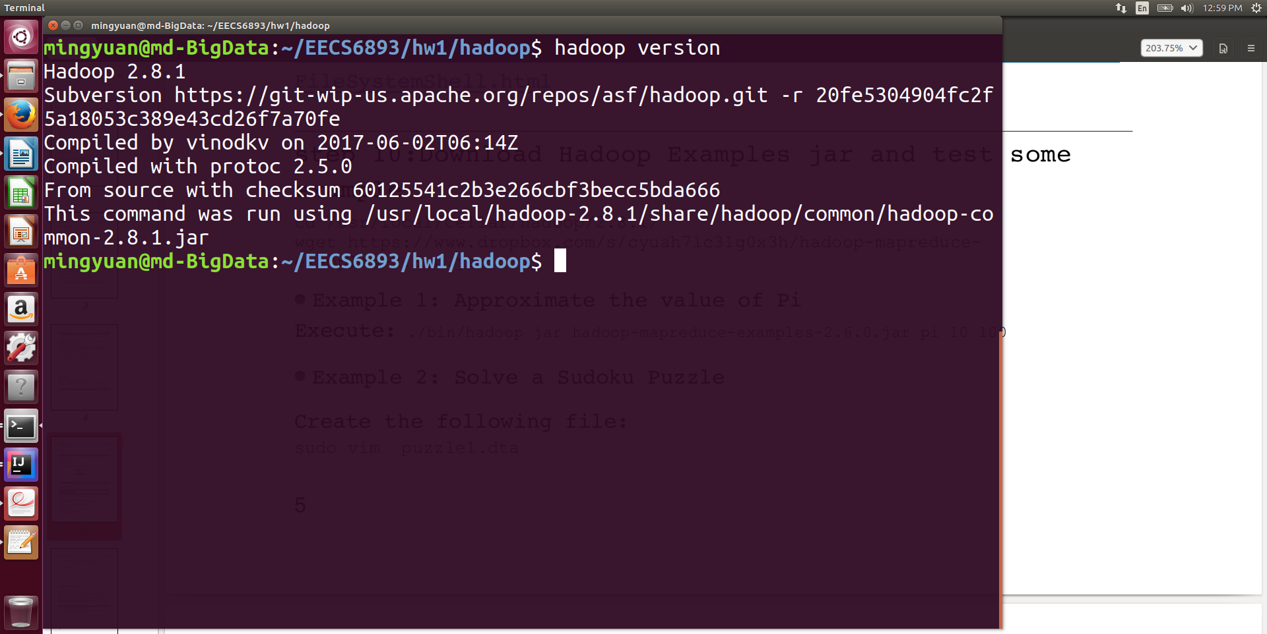

Pic1. Hadoop version check

## Running Hadoop examples

1. Pi calculation

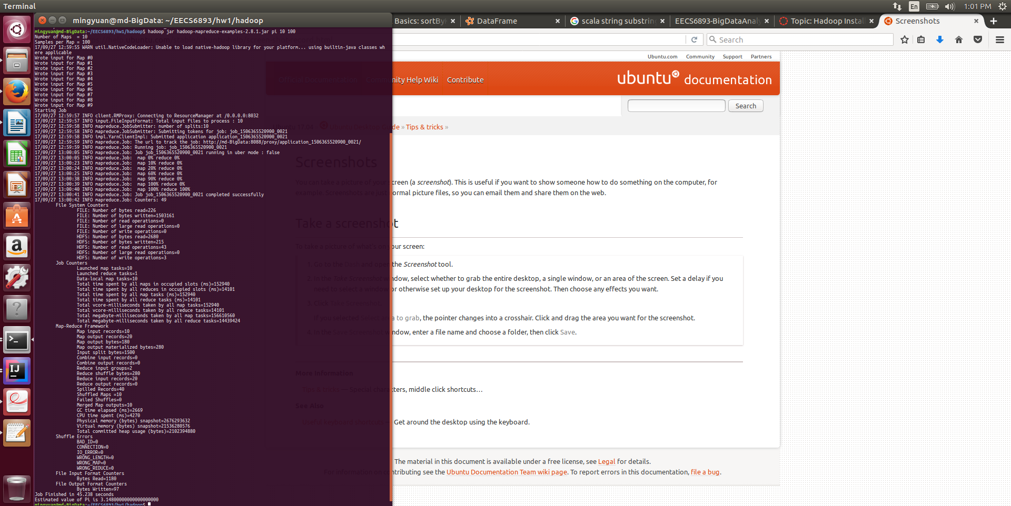

The result of Pi calculation given arguments “10 100” is 3.140000000000000000

1. Sudoku puzzle solution

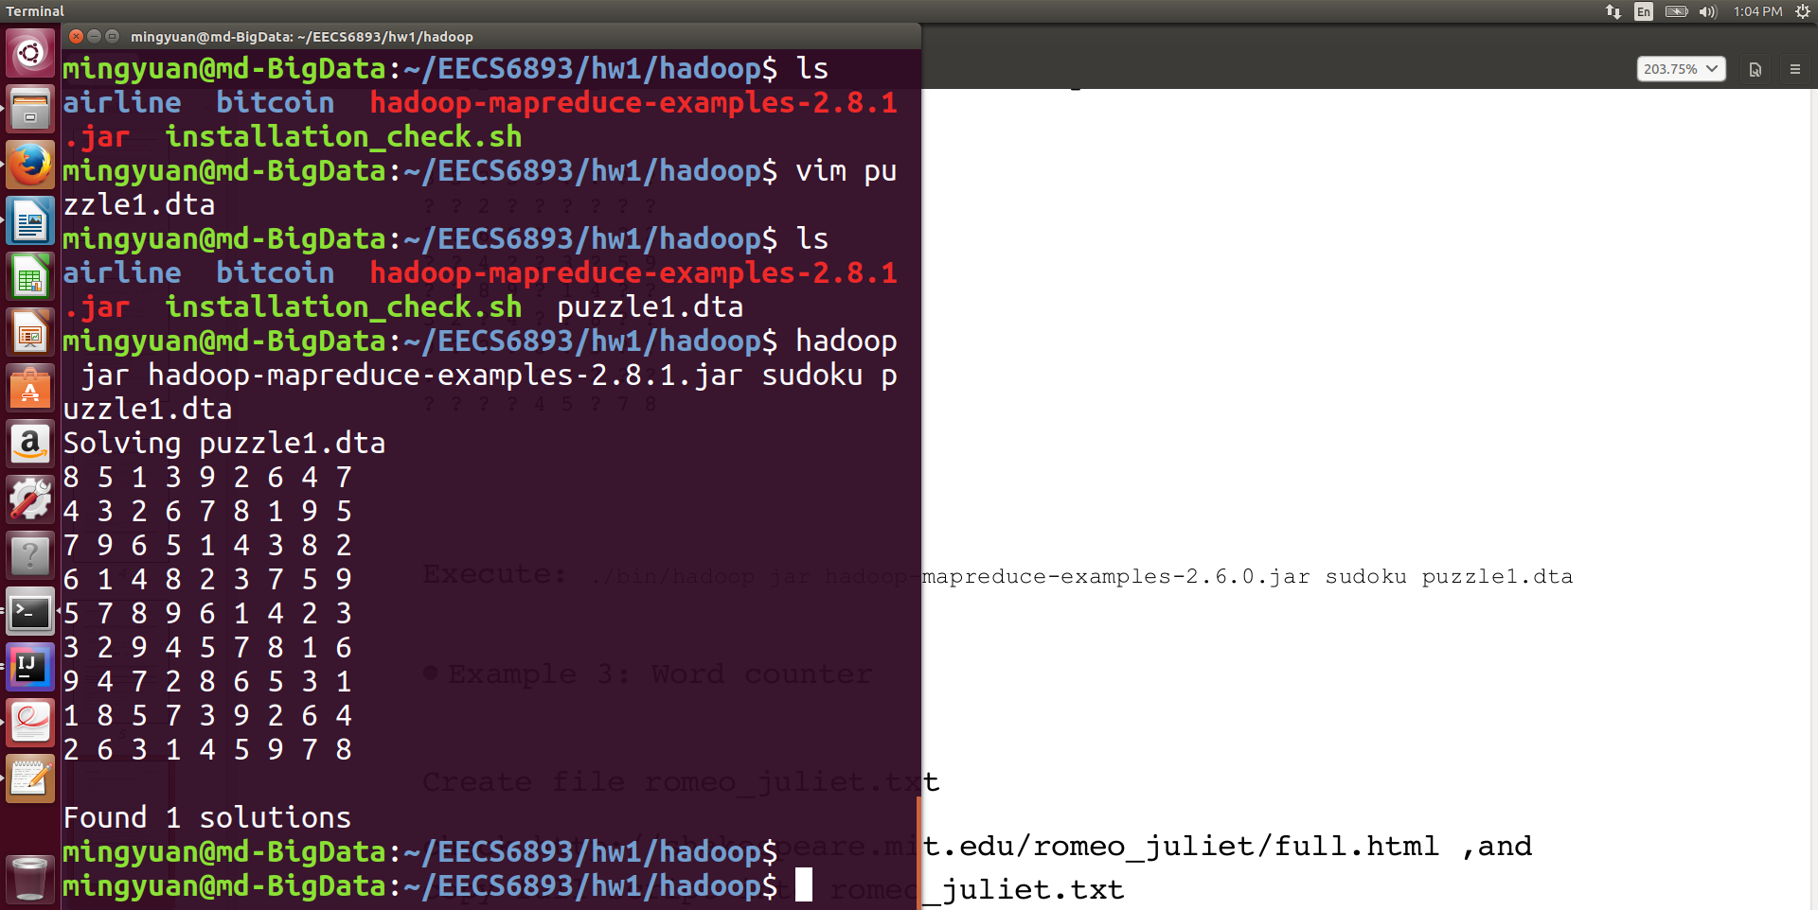

1. Wordcount
   1. Running word count job

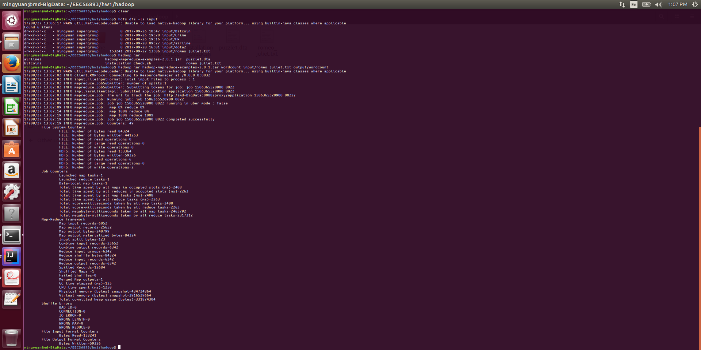

* 1. MapReduce job results

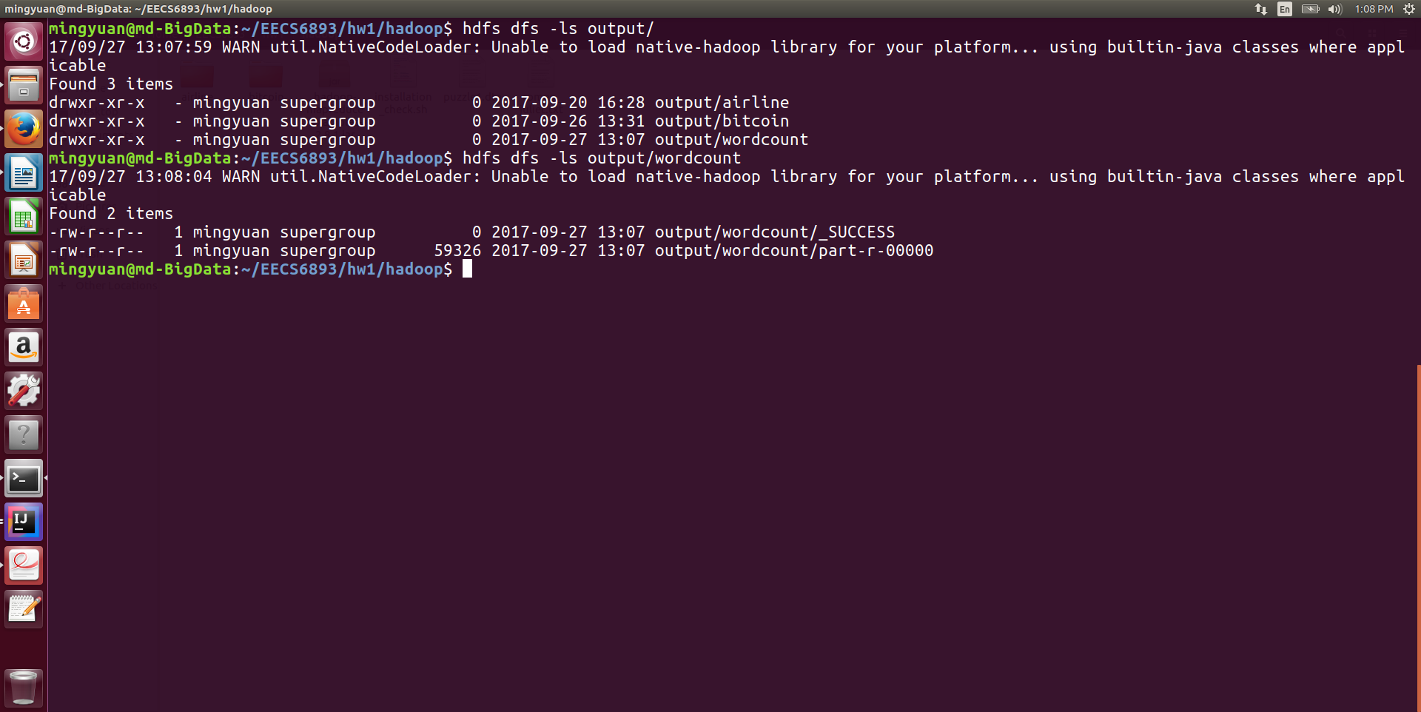



# Hadoop Operation

# Hbase query

For this part I used a dota2 player ratings dataset downloaded from Kaggle. This dataset has 5 columns, which contains the information about each player’s account id, total win matches, total played matches and player’s true skill score.

1. Dataset example

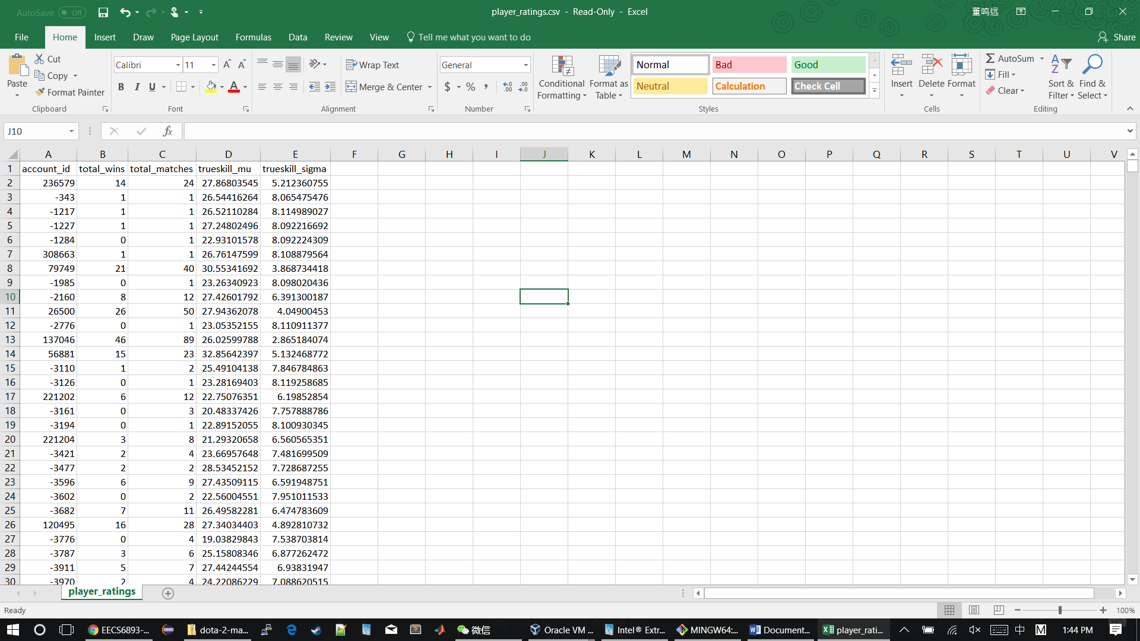

1. Hbase queries
2. Describe Hbase “PlayerRatings” table

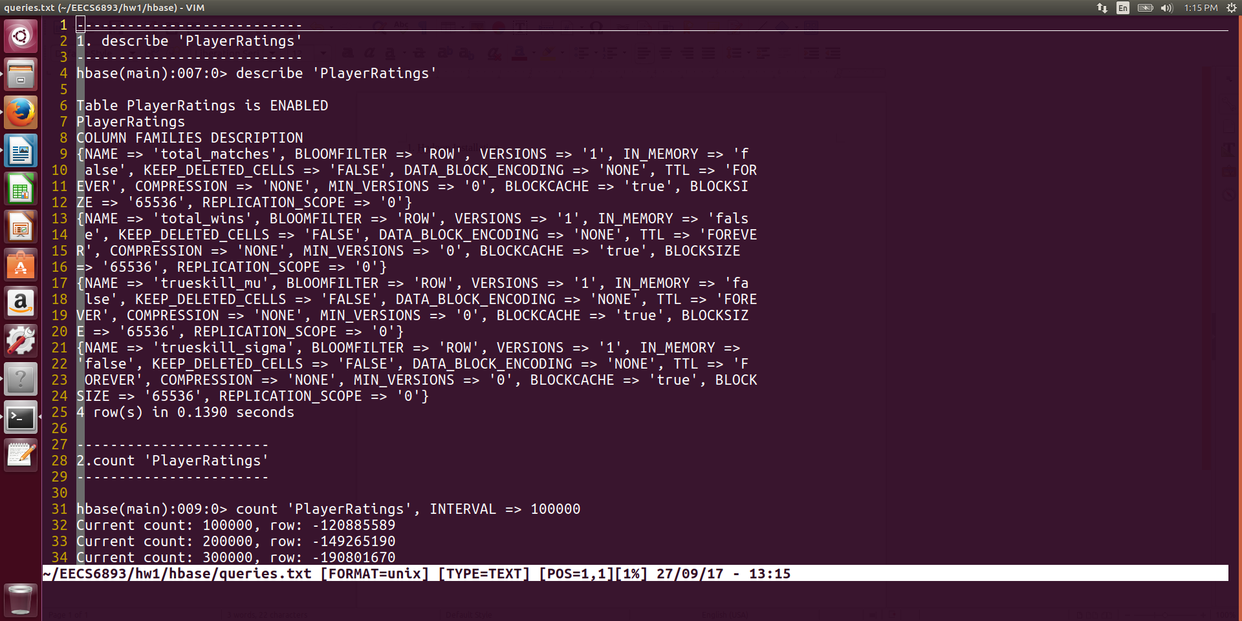

1. Count total rows in “PlayerRatings” table and set INTERVAL to 100000

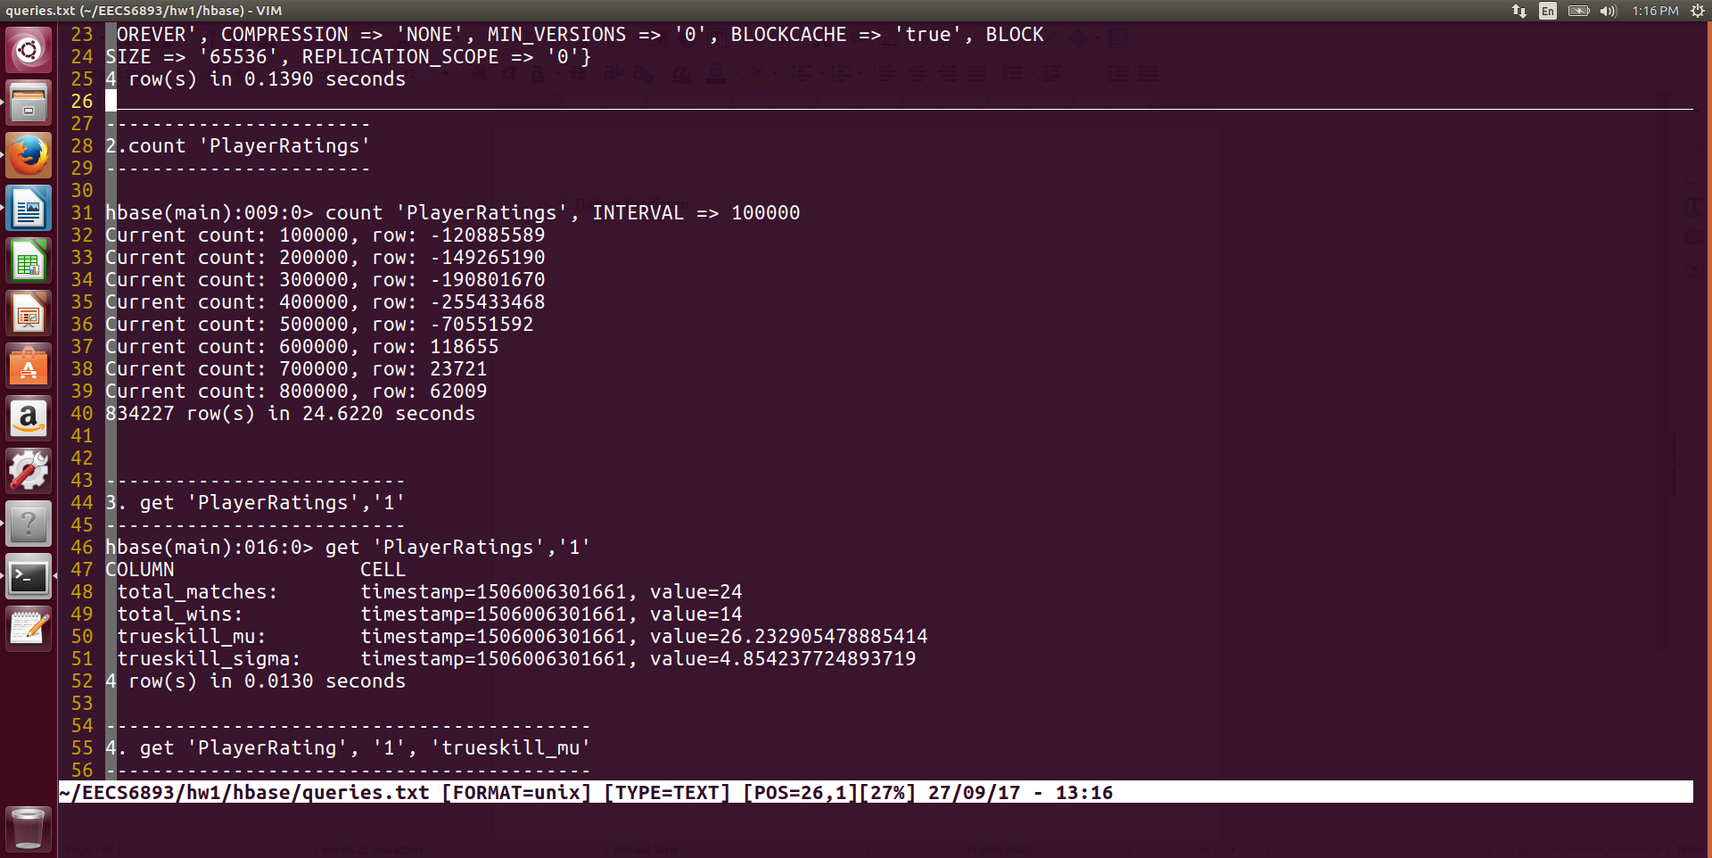

We can see this dataset has 834227 rows and most account id are negative.

1. Get 1 row from table

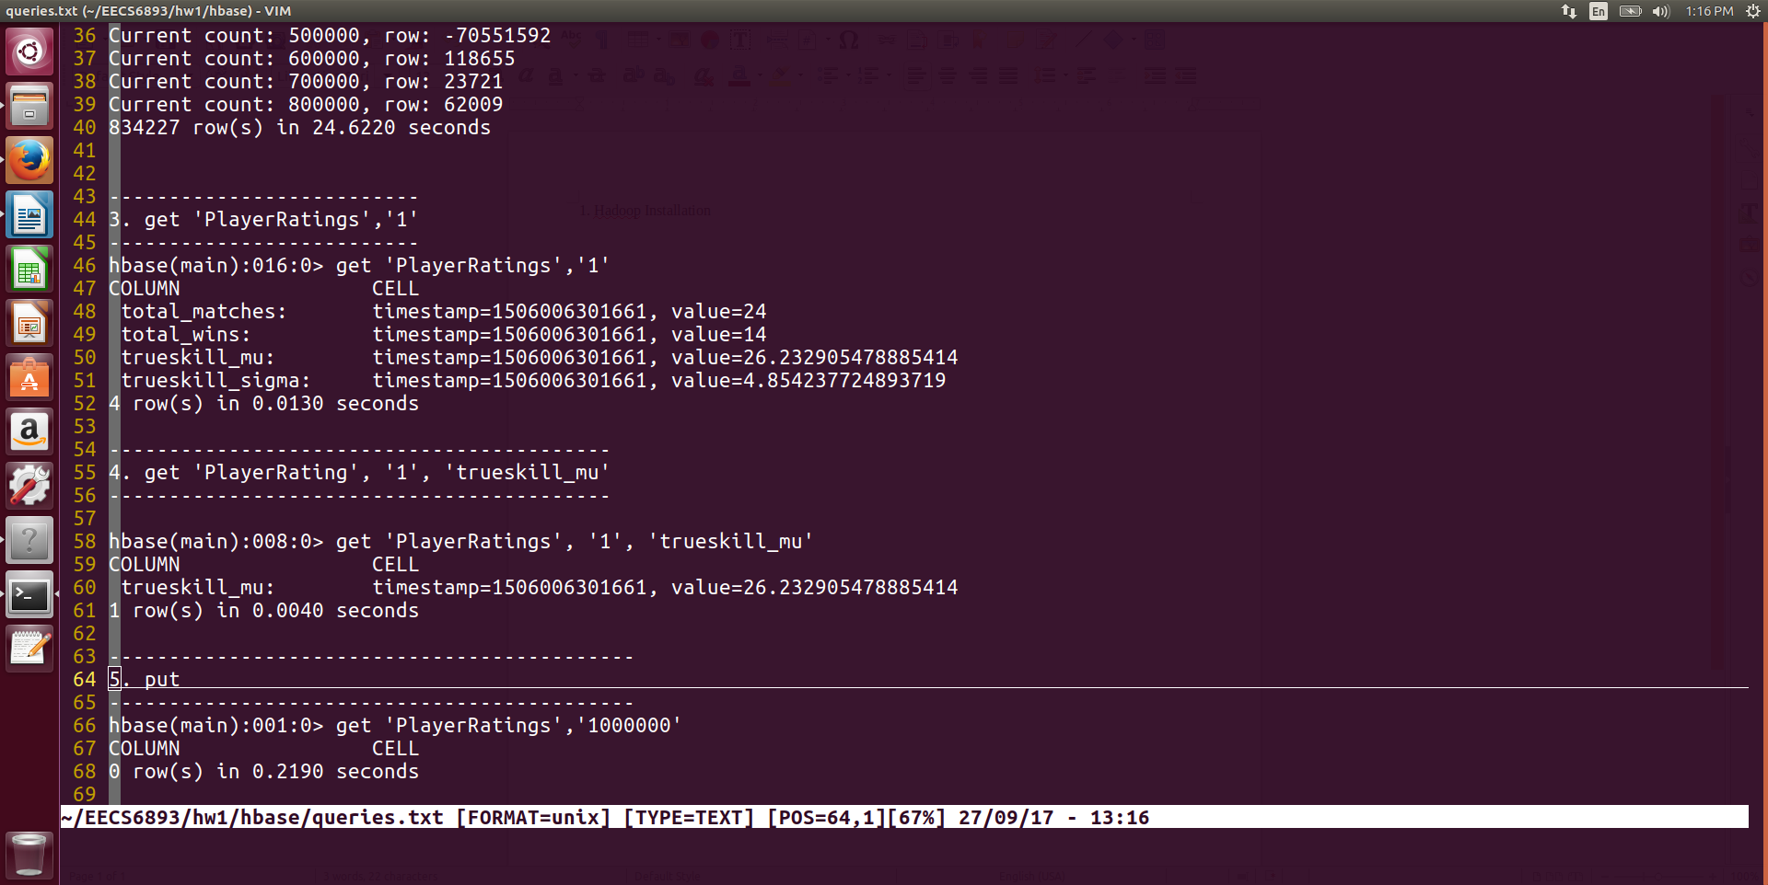

Seems this player has played 24 games and won 14 out of 24, quite a skilled player, right?

1. Get 1 element from table

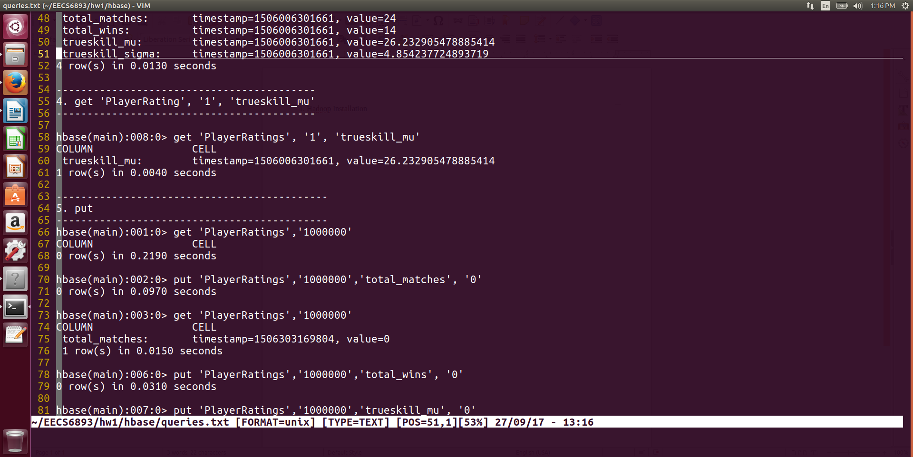

1. Put 1 row into table

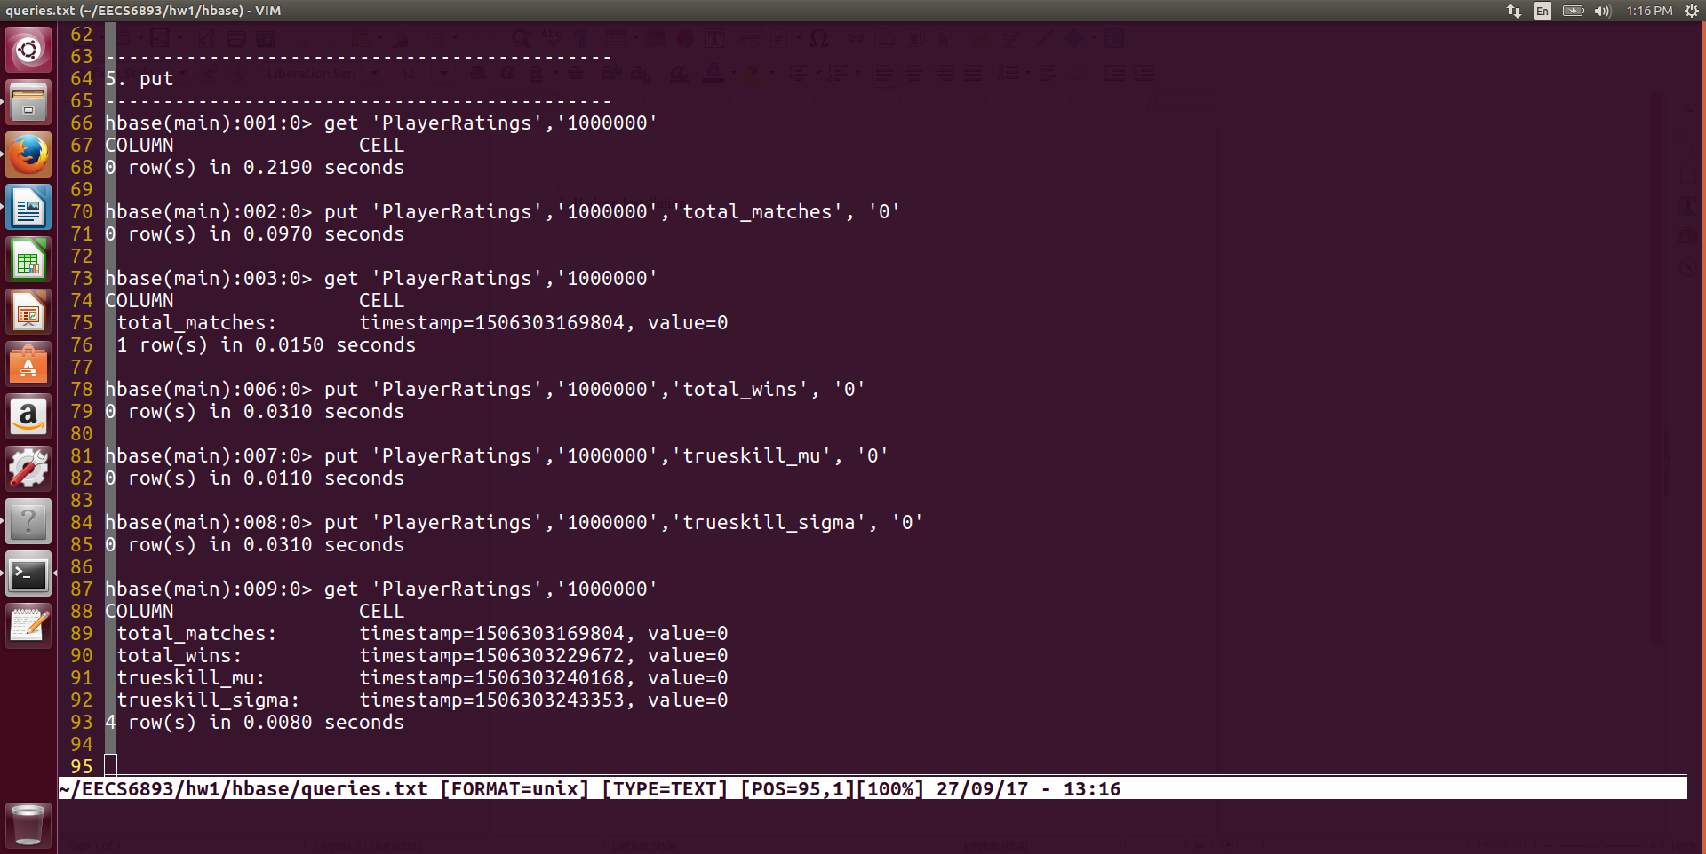

Here I put a dummy player who has never played dota2 into table.

# Hive Query

I am still using the Dota2 dataset in this part since information in this dataset is quite interesting and worth a deeper look. Meanwhile I have loaded other 2 datasets into Hive and Hbase. One is Chicago crime report dataset and the other is a human resource dataset.

1. Create table and load dataset

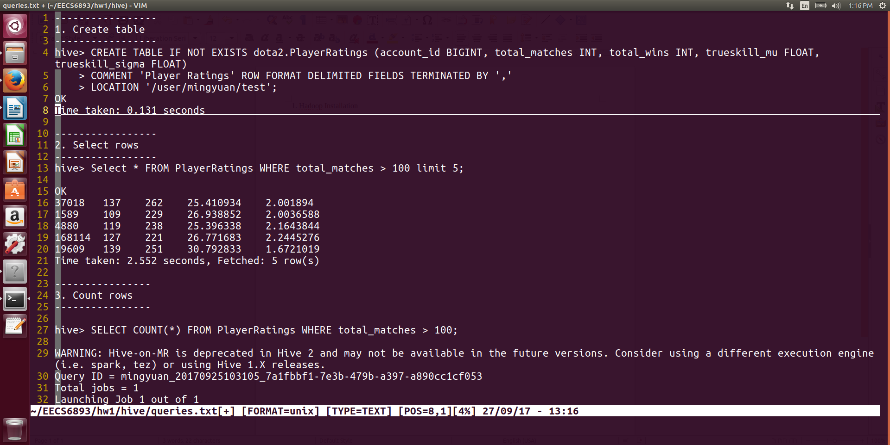

1. Select 5 players who have player more than 100 games



1. Row count

Let’s see how many players out of 834227 have played more than 100 games.

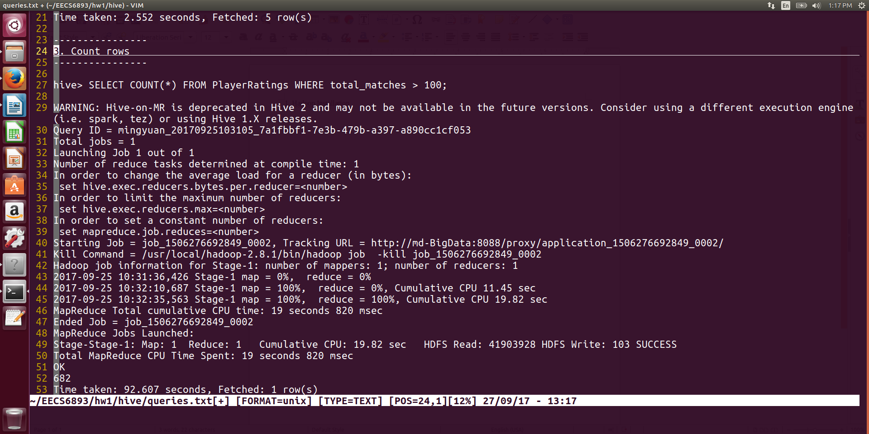

The answer is 682, which is a small number. It means only ~0.1% players in this dataset has played more than 100 games. Not as same as I expected.

1. More complex selection

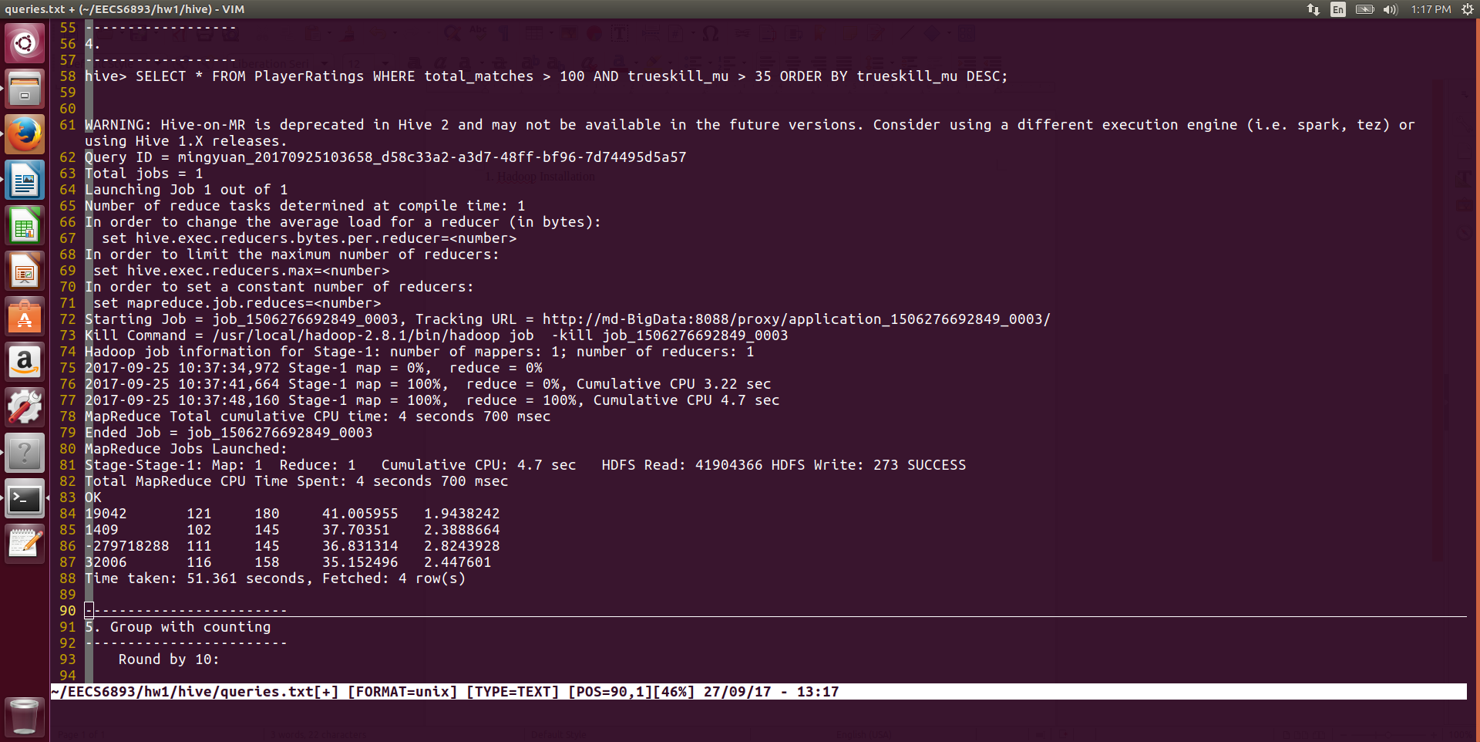

Select players who have played more than 100 games and have high trueskill score. This query only returned 4 players.

1. Group by number of games played

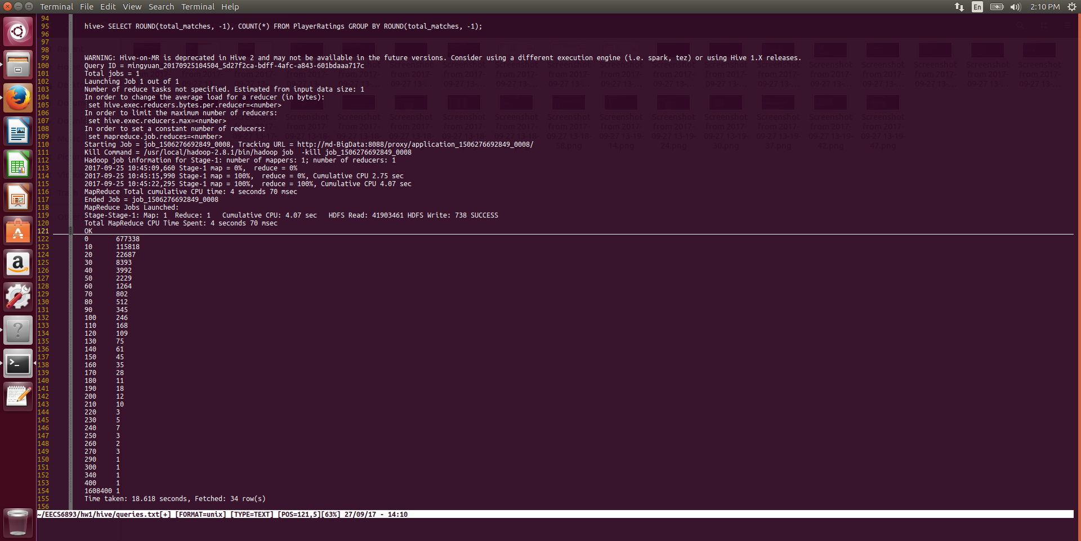

1. Find the maximum trueskill score

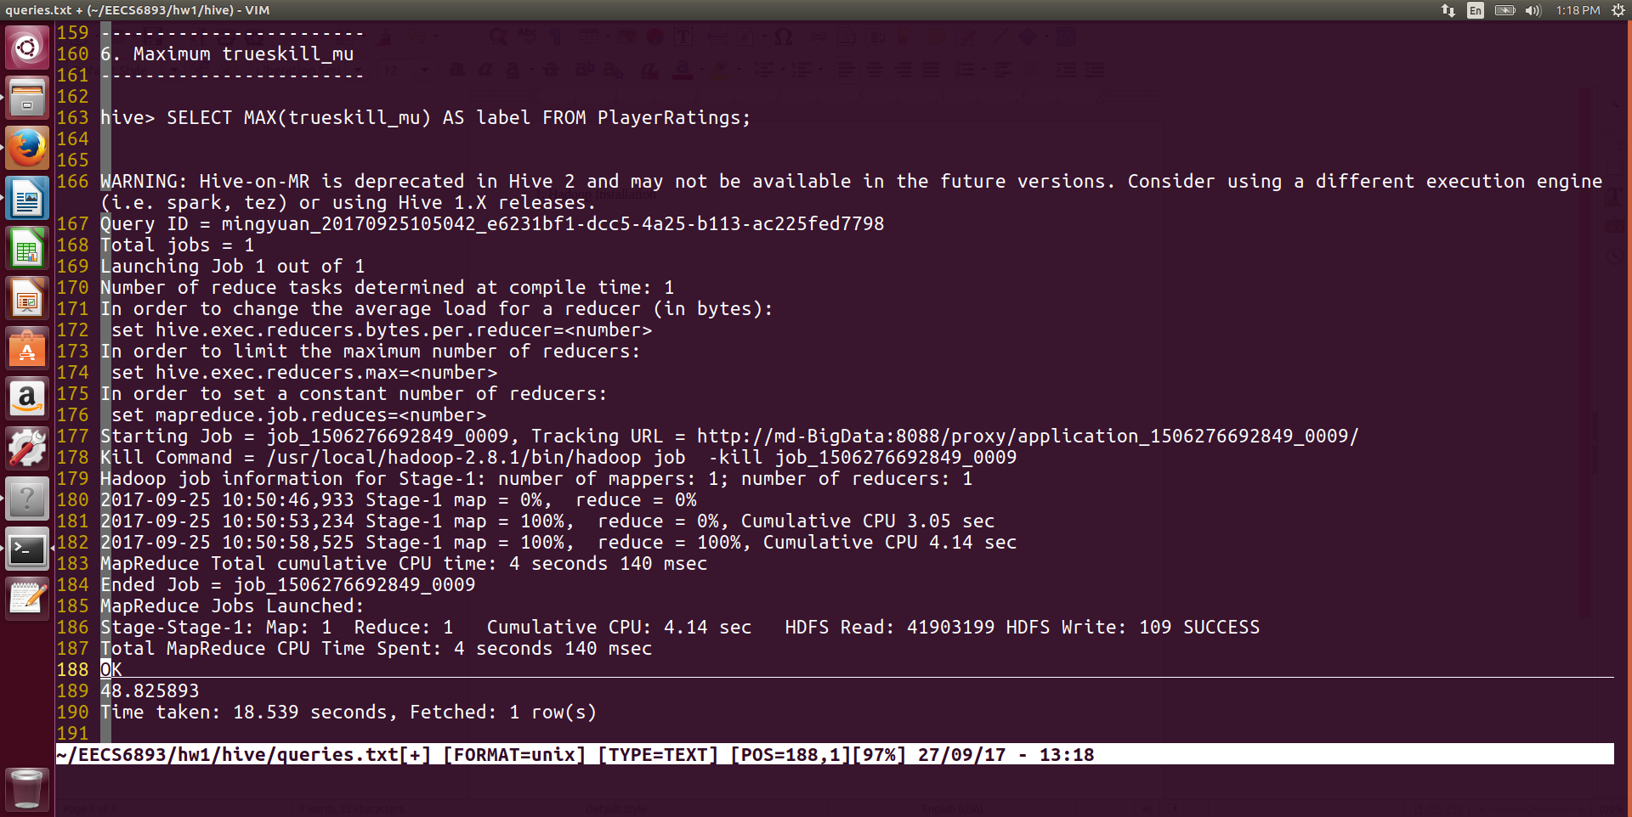

# Airline Dataset Analysis

## Hadoop

1. Hadoop Job
2. Runner class

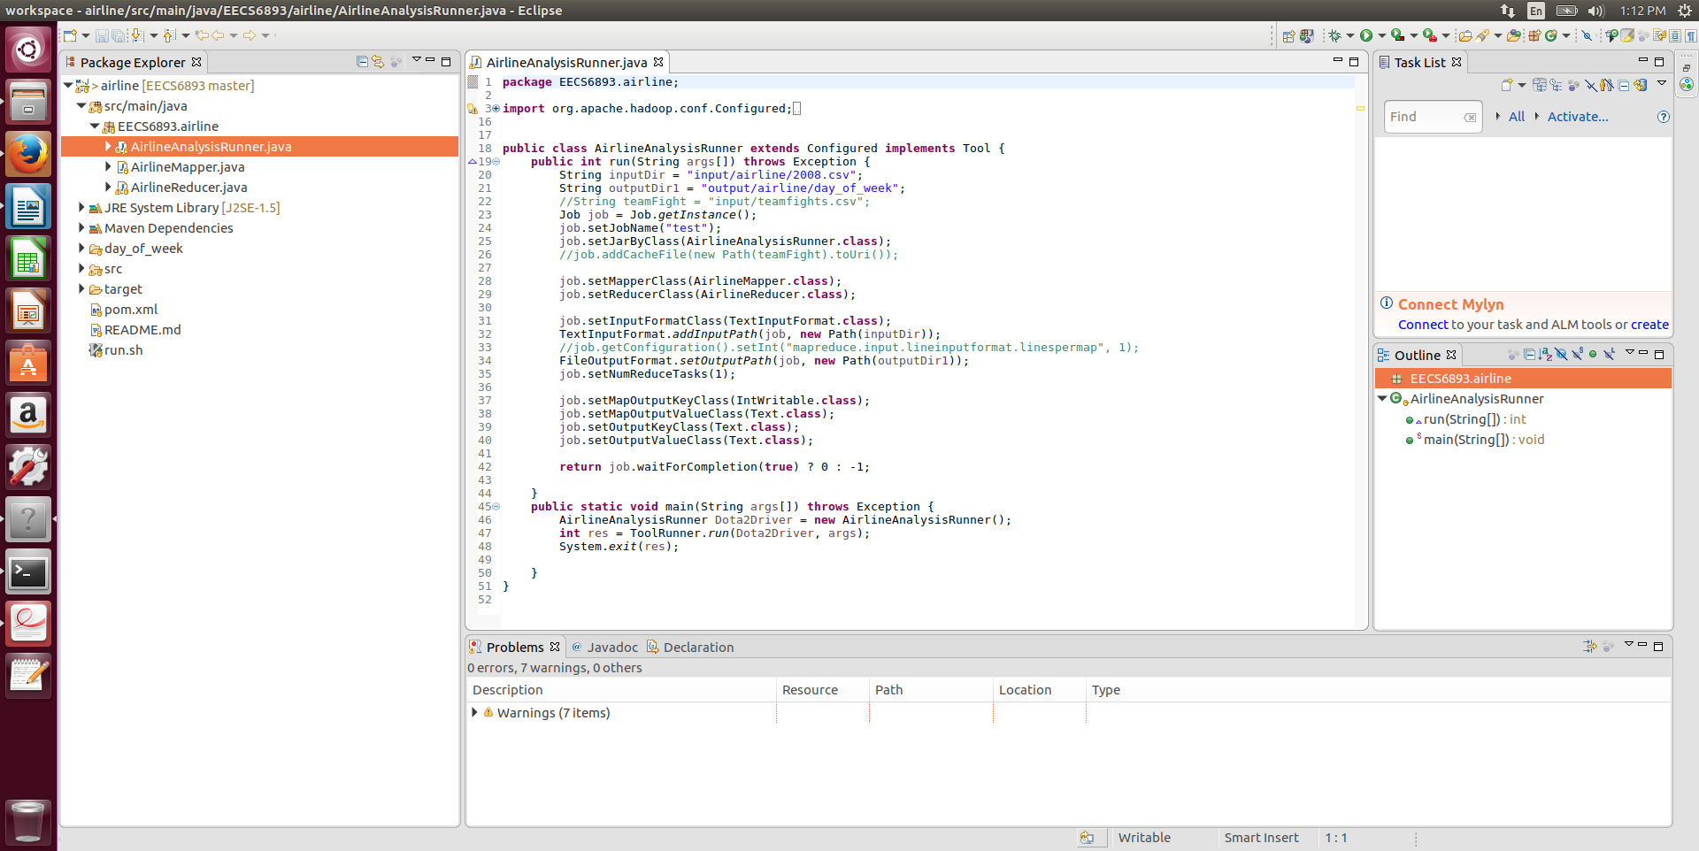

1. Mapper class

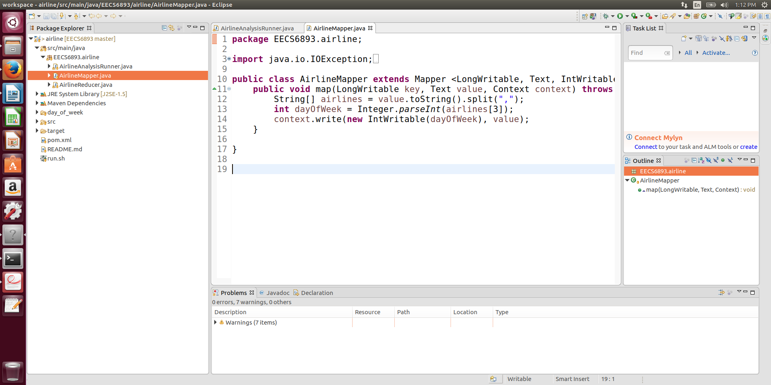

1. Reducer class

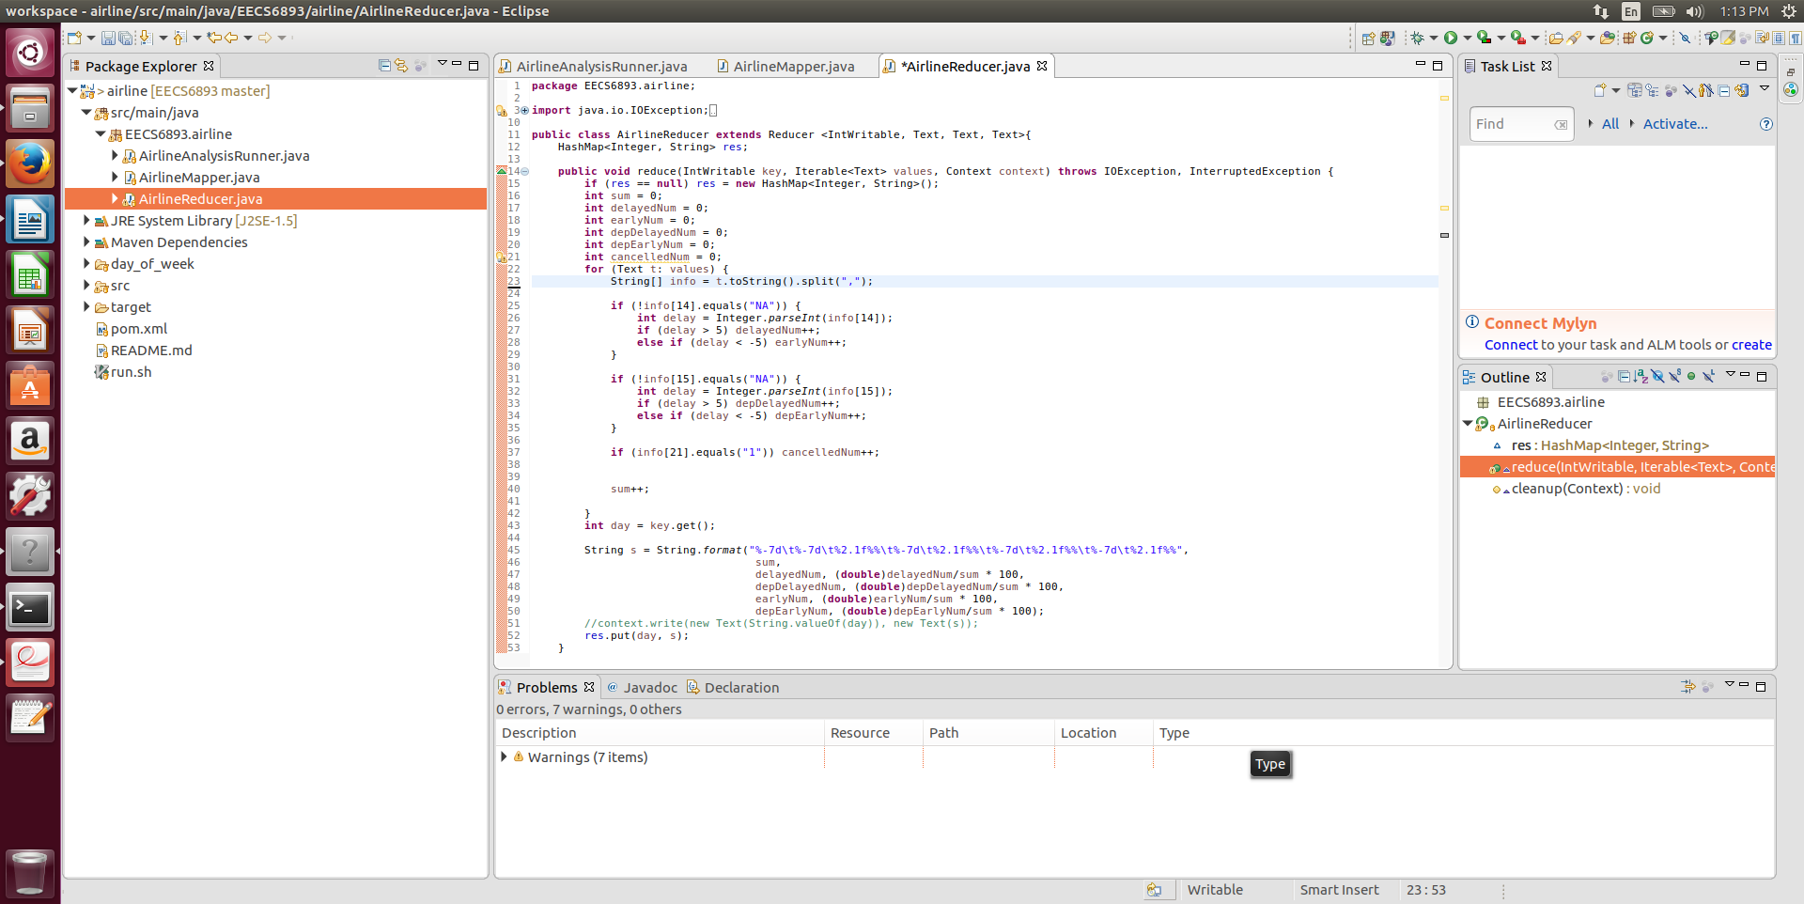

1. Result

In this MapReduce job, I am trying to find the Airline delay corresponding to Day_Of_Week information. And it is obvious that airlines in Friday have higher delay rates, both arrive and departure delay.

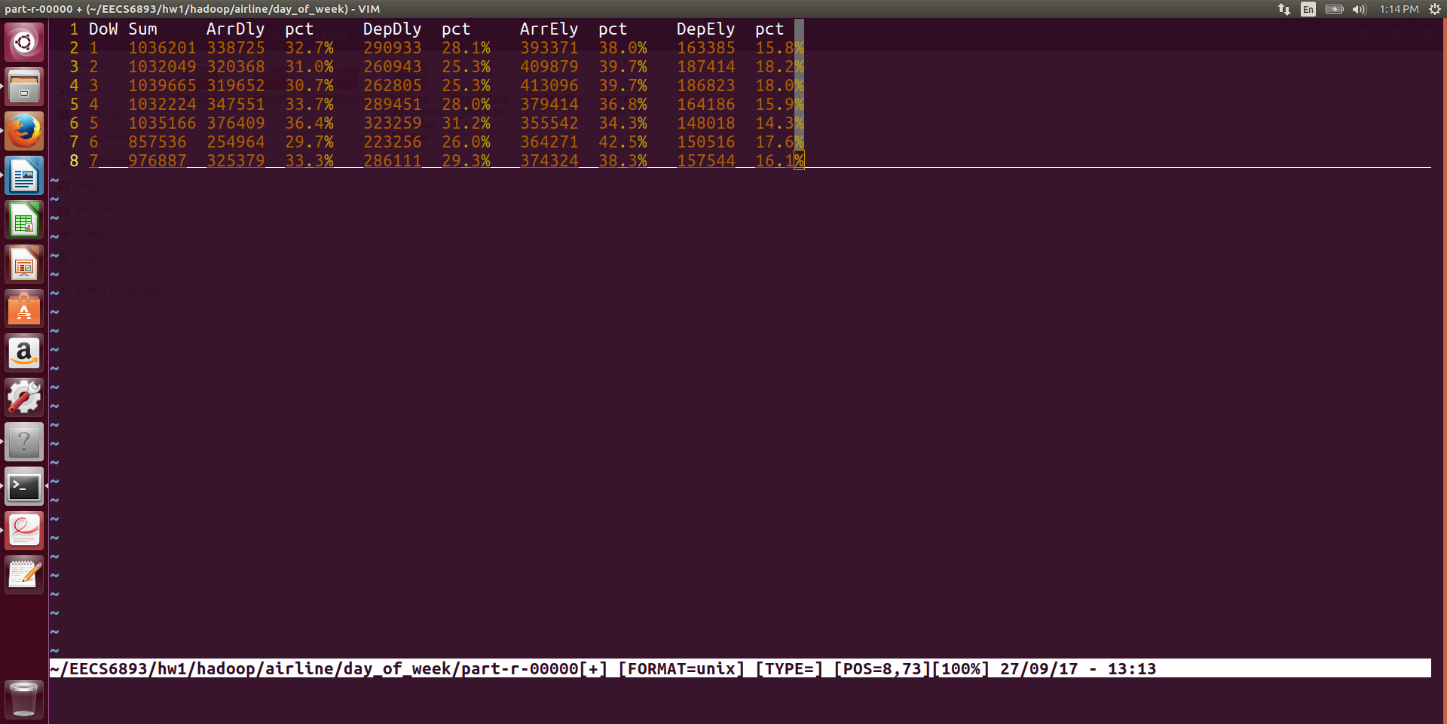

## Spark

1. Spark job

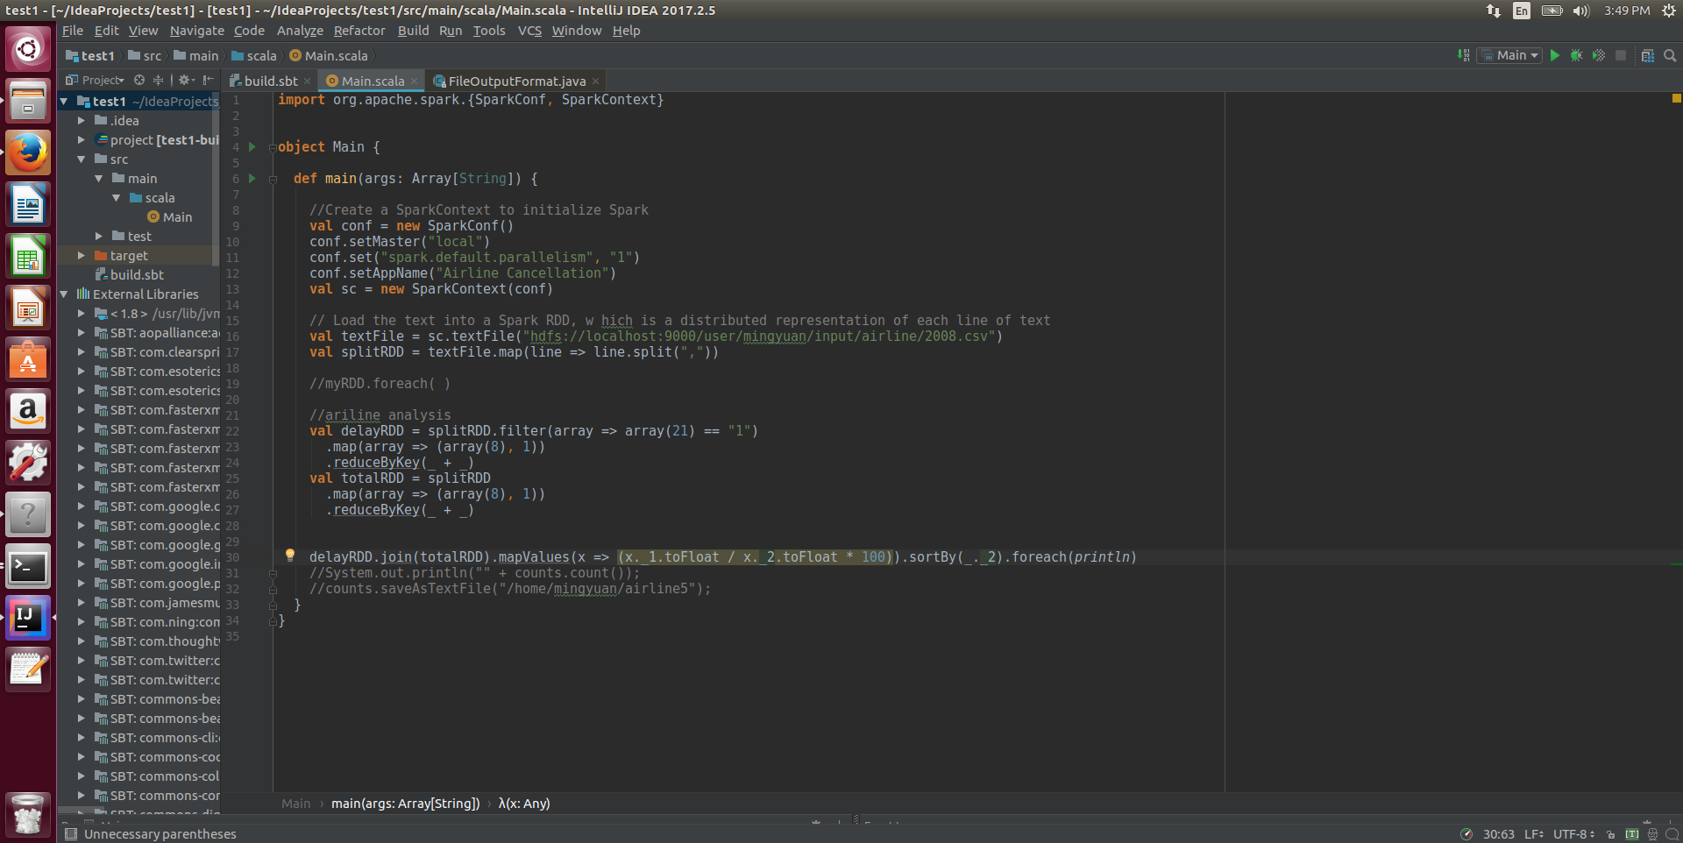

1. Result

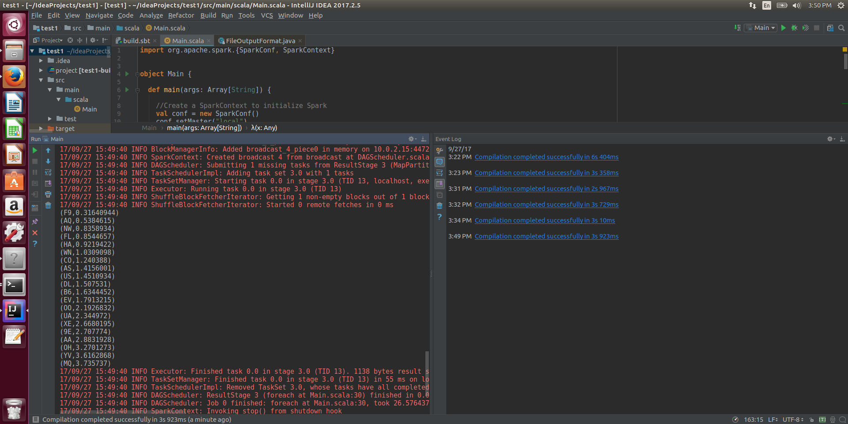

UA has quite high cancellation rate!

# Bitcoin Dataset Analysis

## Hadoop

1. Hadoop Jobs
2. Result

## Spark

1. Spark job

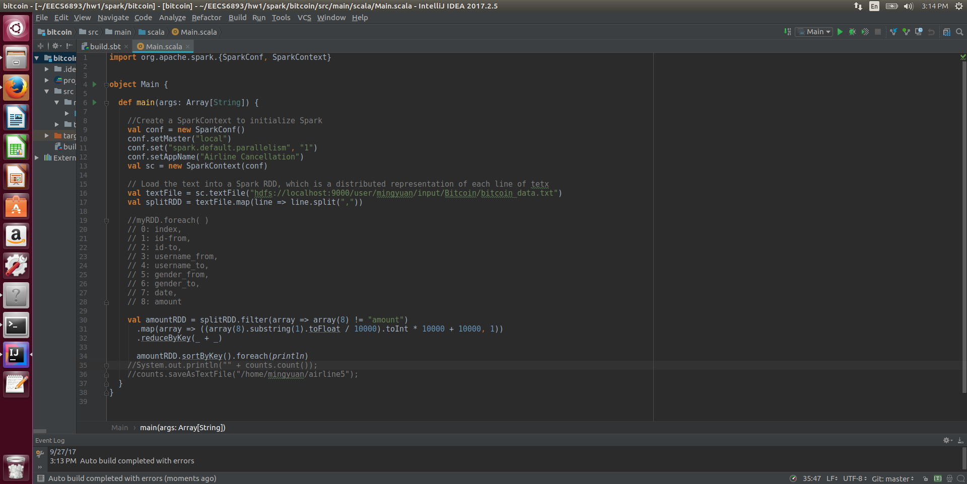

1. Result

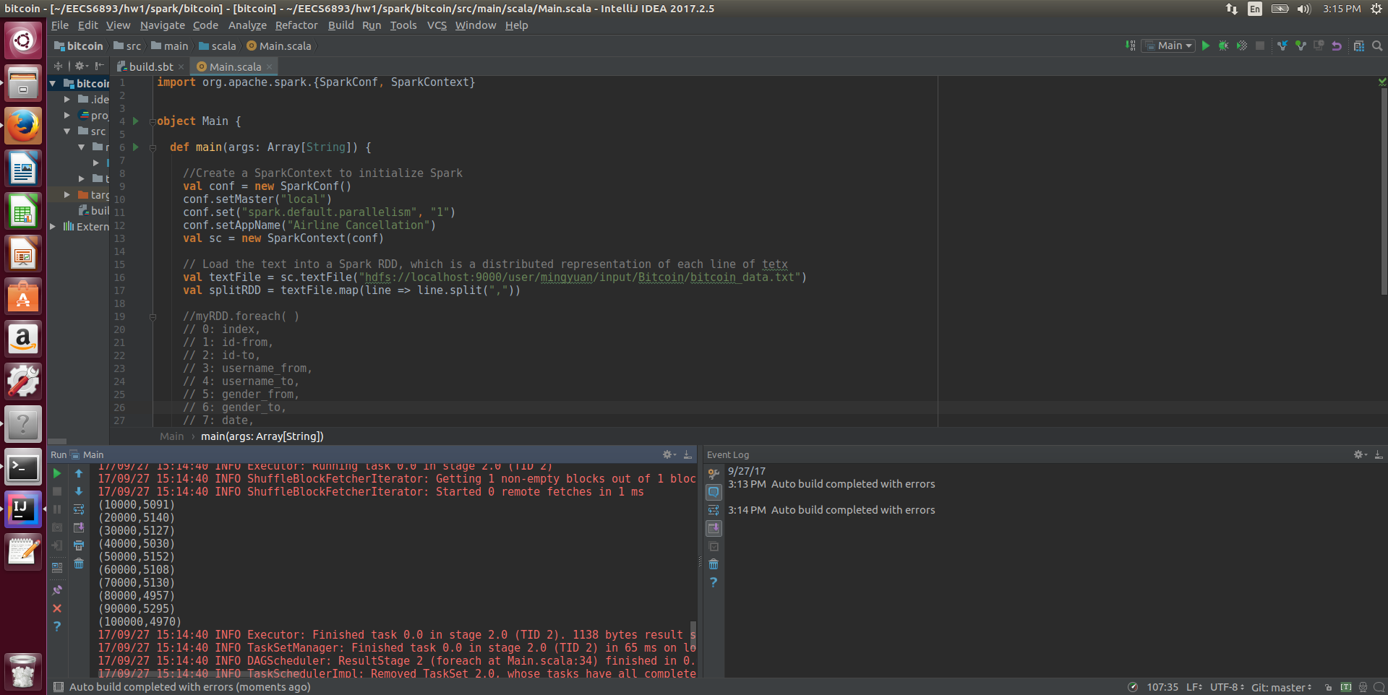

Here I want to investigate the amount of money in each bitcoin transaction. Seems that the amounts of money in each transaction are evenly distributed from 0 ~ 90000 dollars given an interval of 10000. And we can see that many people are using bitcoin to send large amount of money (~$100000).

# Other analysis

## Spark

1. Load data
   1. Define schema

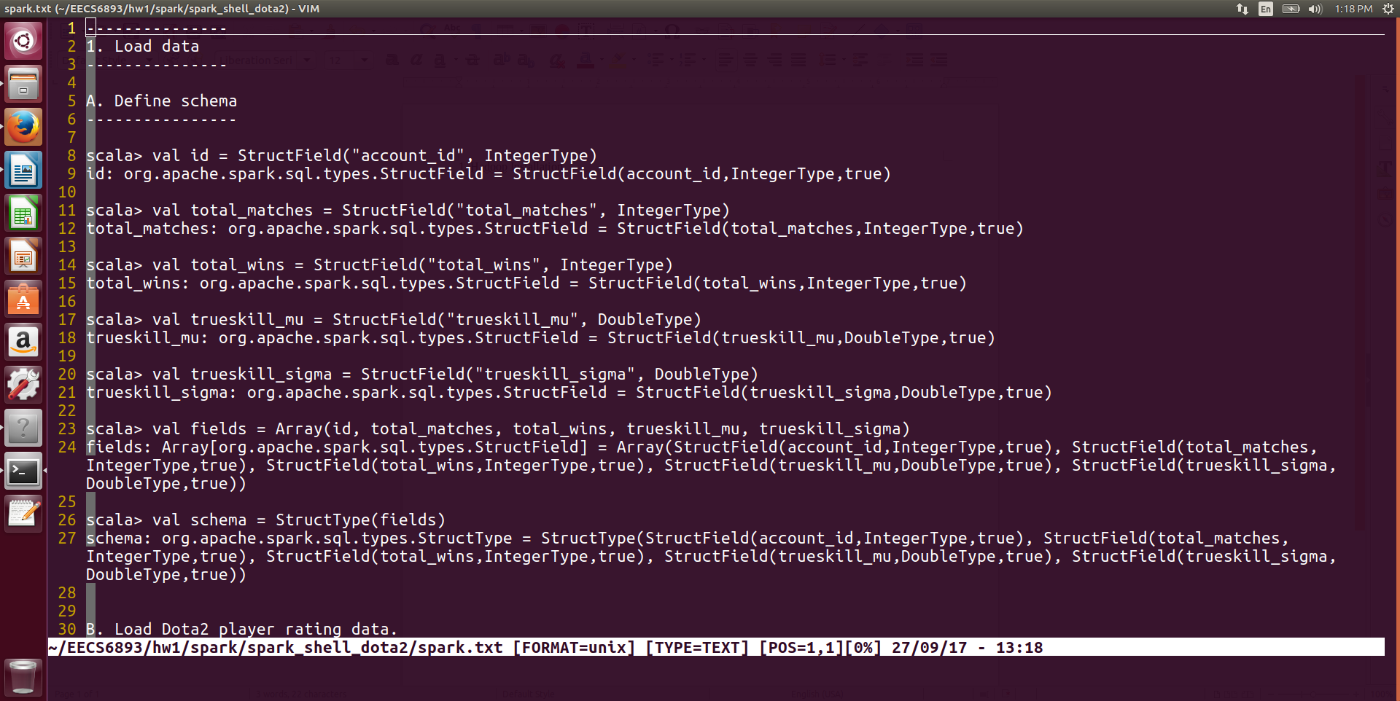

* 1. Load Dota2 player rating data

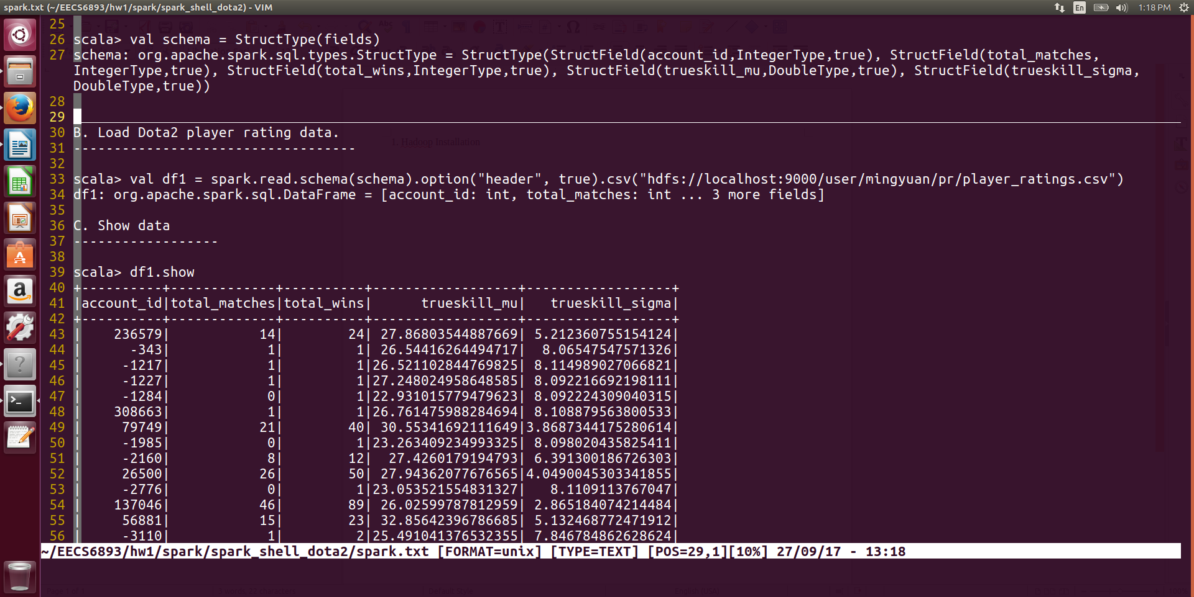

* 1. Show data

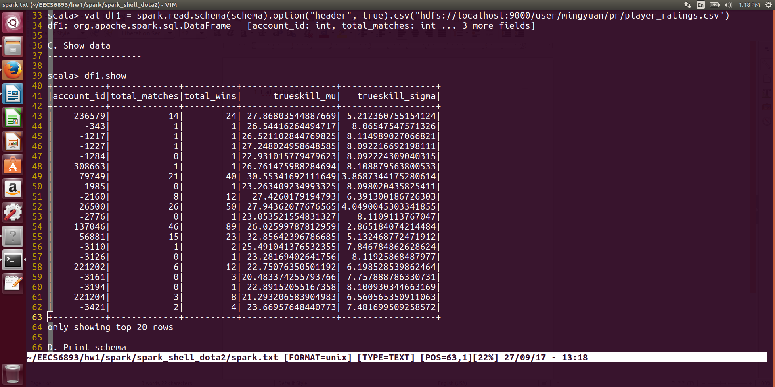

* 1. Print schema

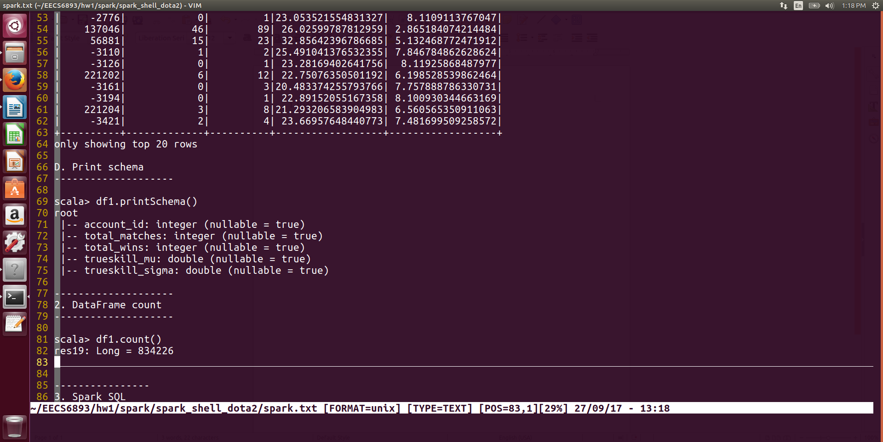

1. DataFrame count

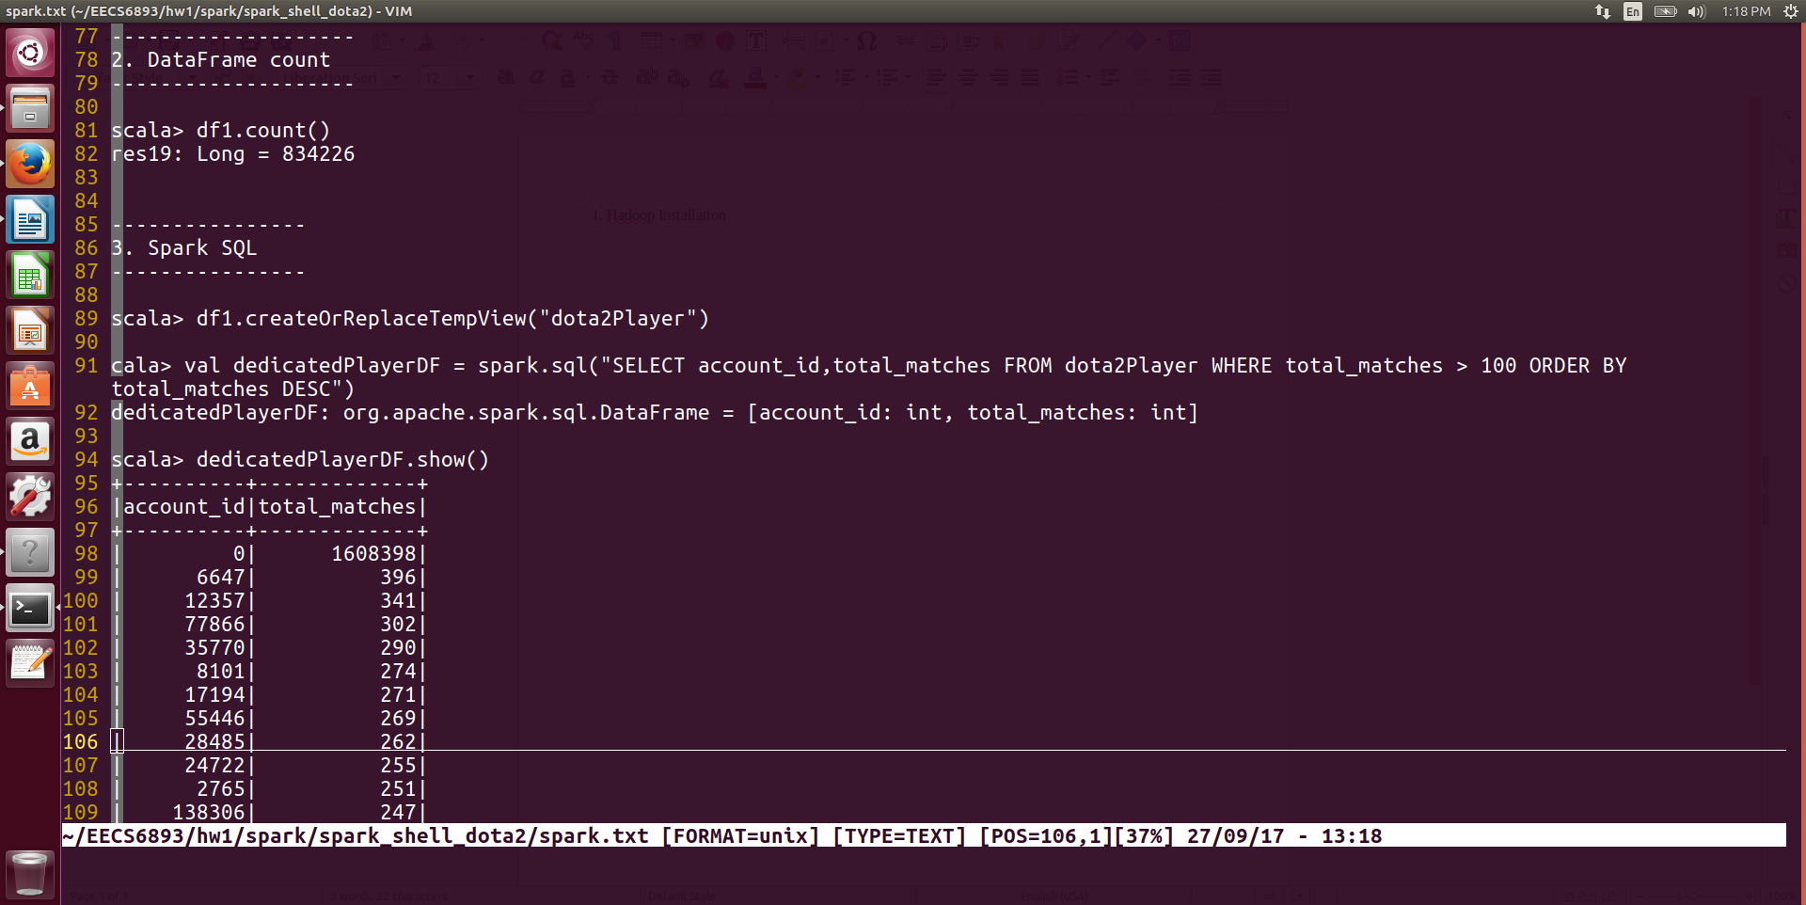

1. Spark SQL

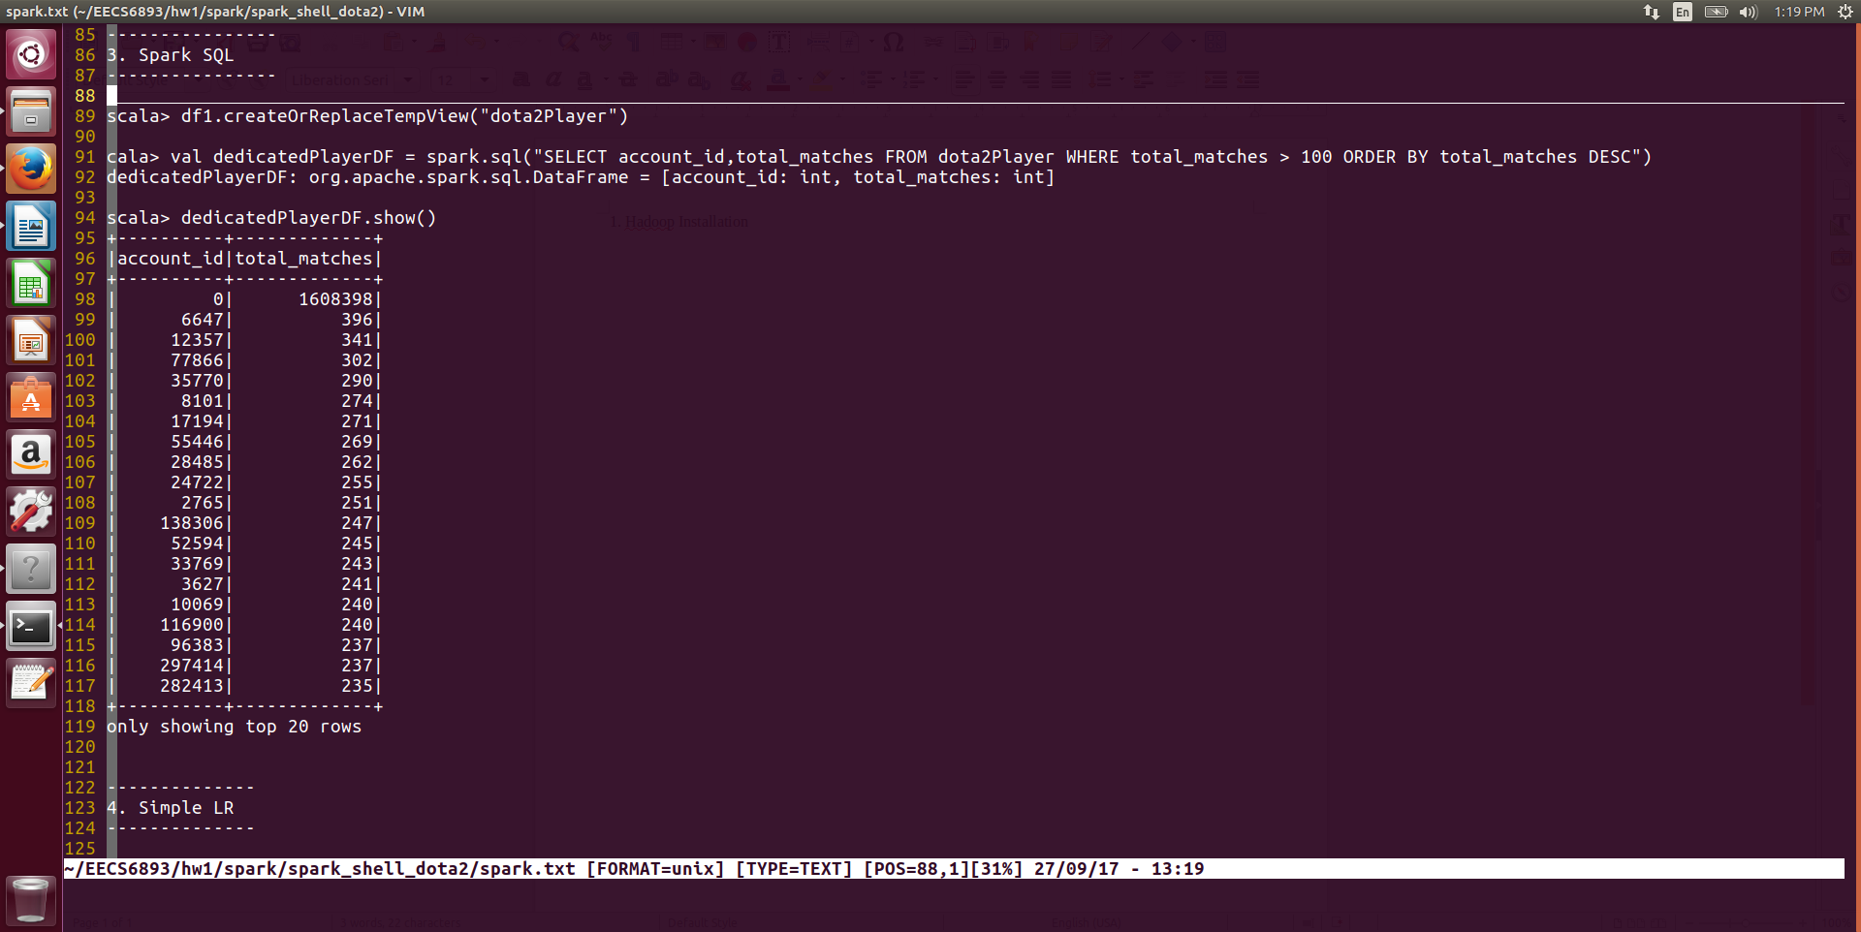

Select player who has played more than 100 games. There is a player who has played 1608398 which is impossible. Might be a problem caused by csv header.

1. Naïve Linear Regression
   1. Features assembler

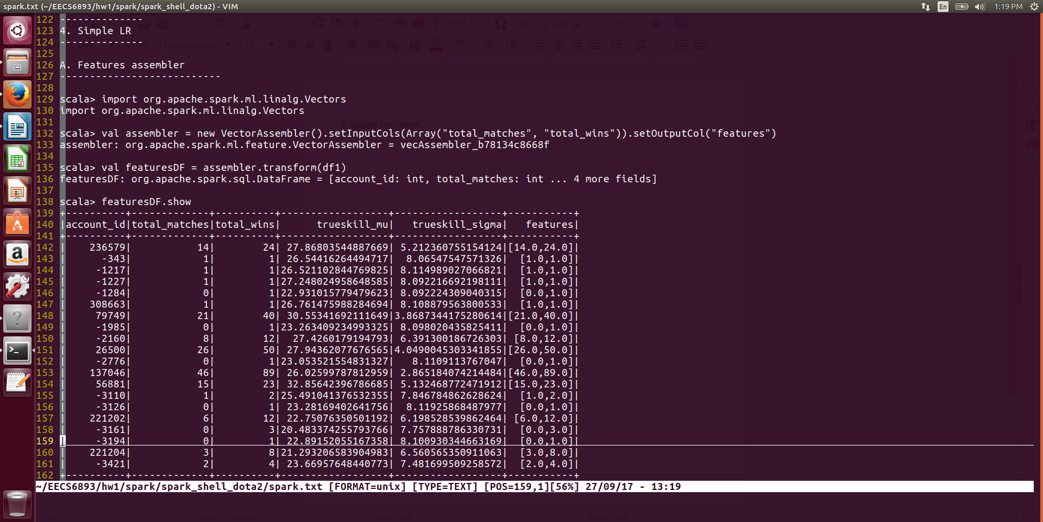

* 1. Change column names

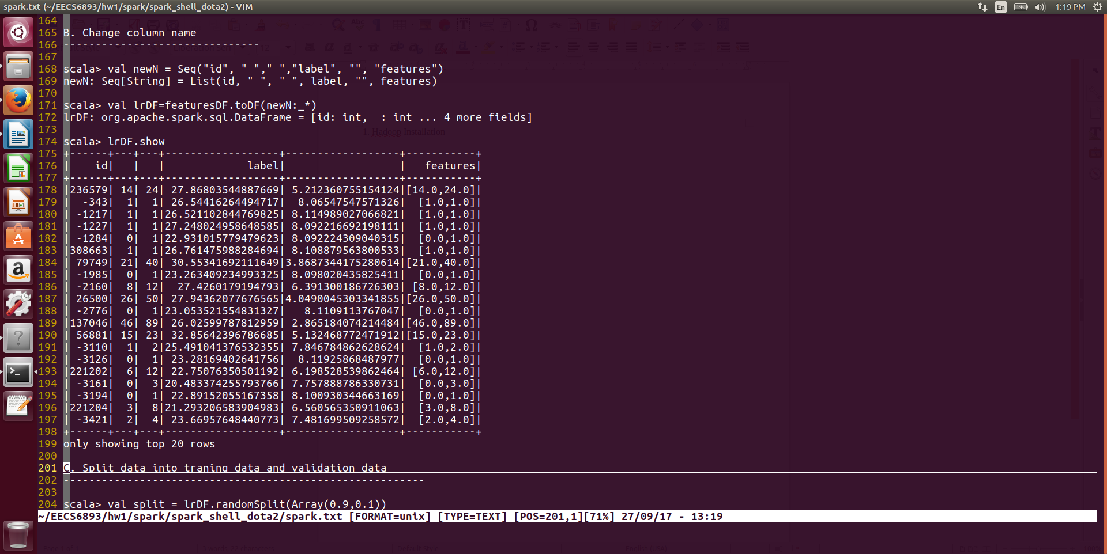

* 1. Split data into training set and validation set

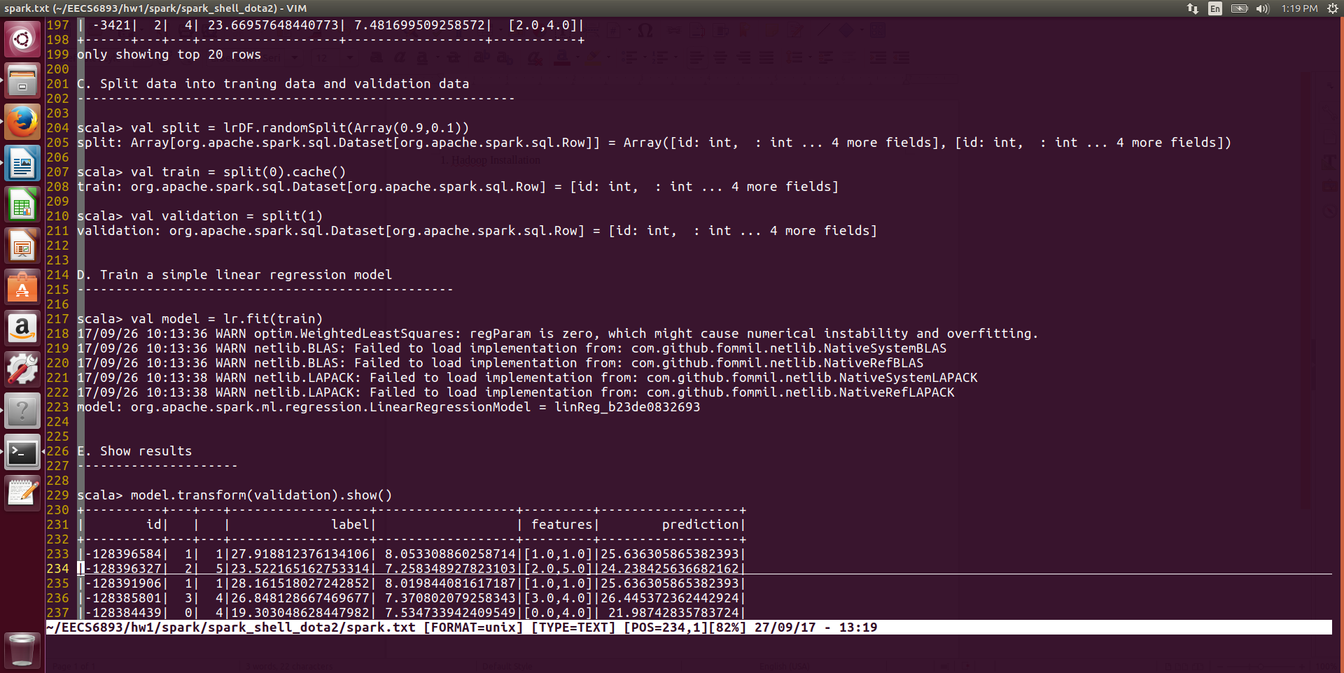

* 1. Train a simple LR model



* 1. Show results

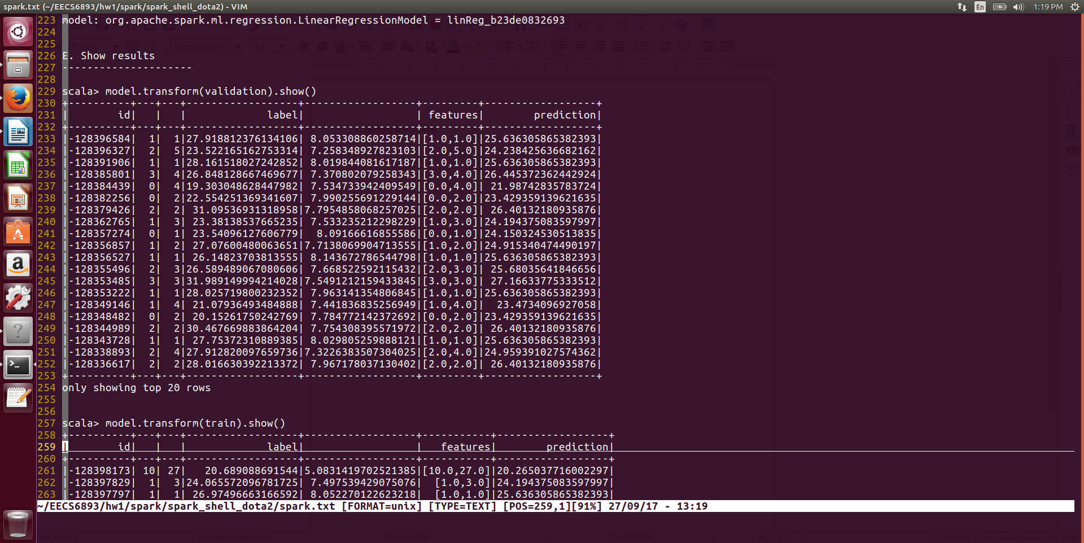

Validation Set

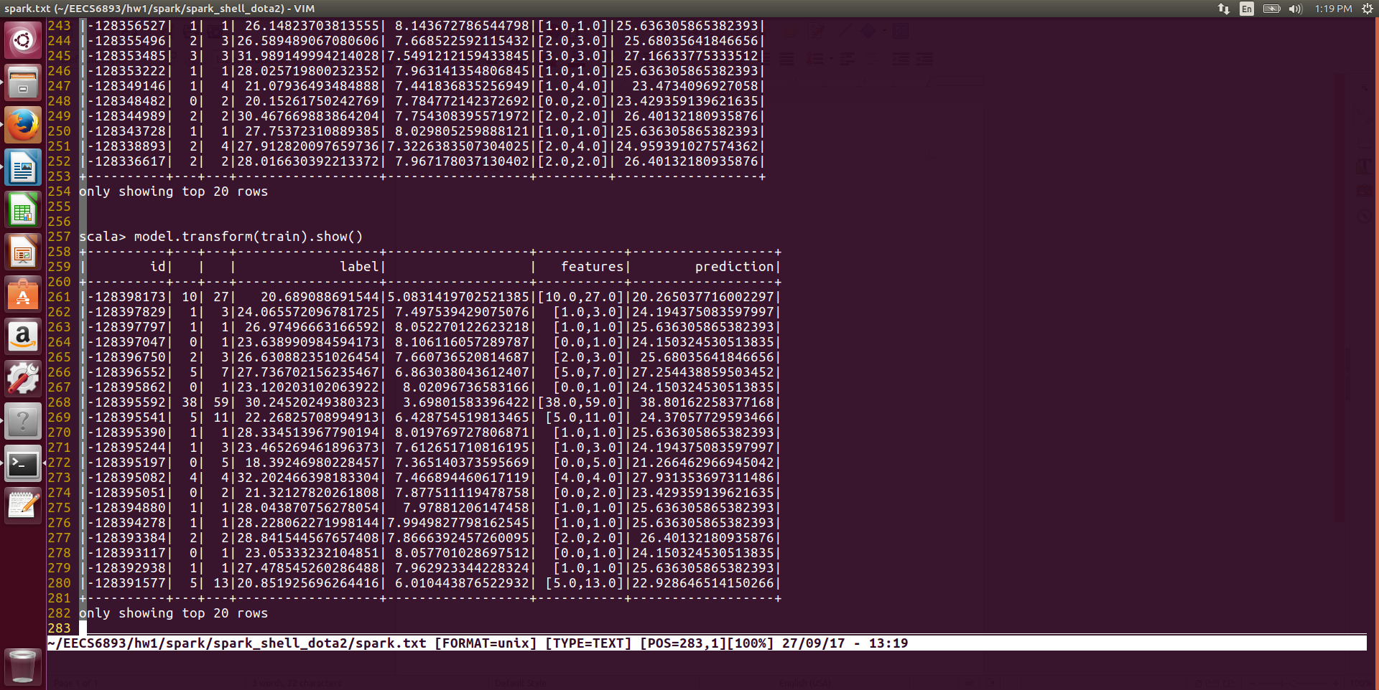

Training Set